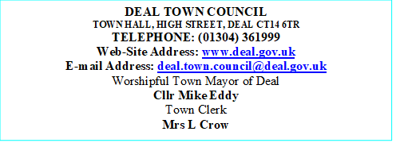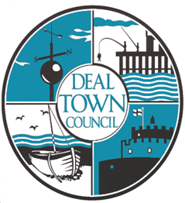
ALLOTMENT REQUEST FORM
For Deal Town parish residents. If outside of this area, please contact your own local council office.
Date:
Surname:
Forenames:
Address, (This must be in Deal Town Parish and be your primary residence).

Telephone Number:
Mobile Number:
Email:
Deal Town council is committed to cutting our carbon footprint, so email will be our primary method of communication.
Allotment Site – Please number accordingly to preference or tick ANY
Golf Road-
Mill Road-
Park Avenue-
Any-
Deal Town Council cares to ensure the security of personal data. This is done through appropriate technical measures and relevant policies.
Data is kept for the purpose it was collected for and only for as long as is necessary. (See our Privacy Notice & Retention Policy online at: www.deal.gov.uk for further information)

