Deal Town Council
Used E-bike transfer application form 2026

Introduction

As part of the Council’s Cycle Friendly Deal project in 2020 the Council purchased
eight E-bikes that were hired out to members of the public by the Council’s agents. During this time, the E-Bikes were maintained by the agents and serviced annually by the supplier. This project has closed.

Deal Town Council now has six E-bikes that are available for transfer ownership to local charitable organisations for their own use, at no further cost or liability to the council.

The six E-bikes each come with the two batteries and one charger that were all originally supplied by the manufacture’s agent. (not aftermarket).

The E-Bikes models available are:
2x Ezee Bike Sprint (Step-Through model)
1x Ezee Bike Forza (Step-Through model)
2x Ezee Bike Forza (Cross bar model)
1x Ezee Bike Expedir (Step-Through model)

The Council’s Finance and General Purposes Committee will consider all applications for transfer received.

The closing date for applications is Monday 14 July 2026 at 5.00pm.

Photos of Ezee bikes
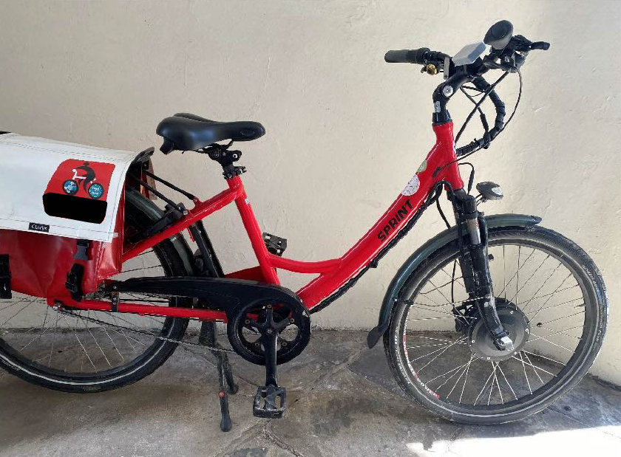

2x Ezee Bike Sprint
(Step-Through model)
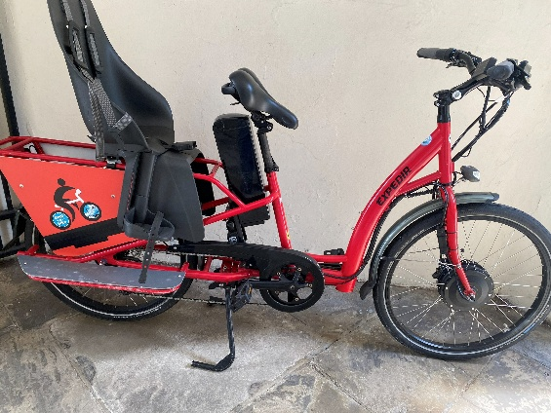
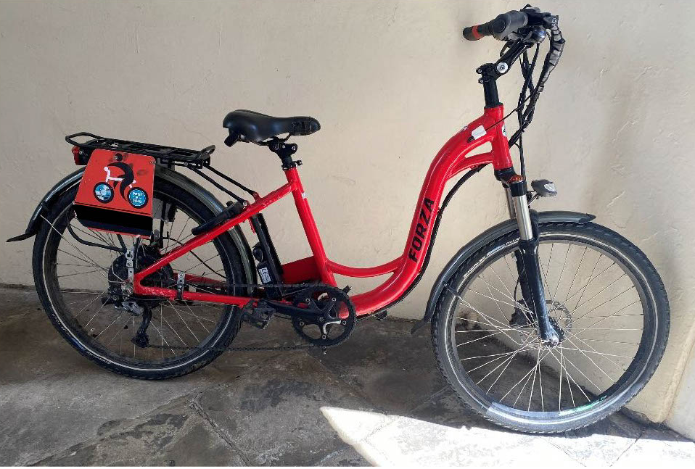

1x Ezee Bike Forza
(Step-Through model)

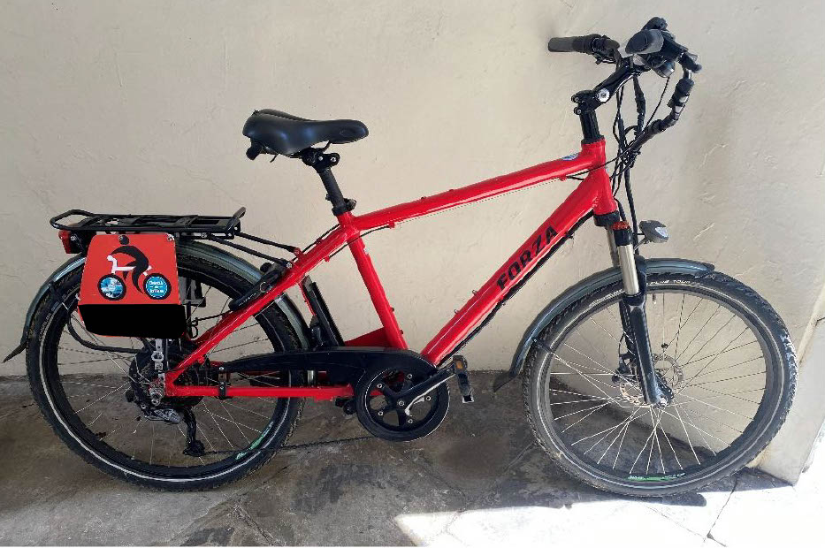

2x Ezee Bike Forza
(Cross bar model)

1x Ezee Bike Expedir
(Step-Through model)

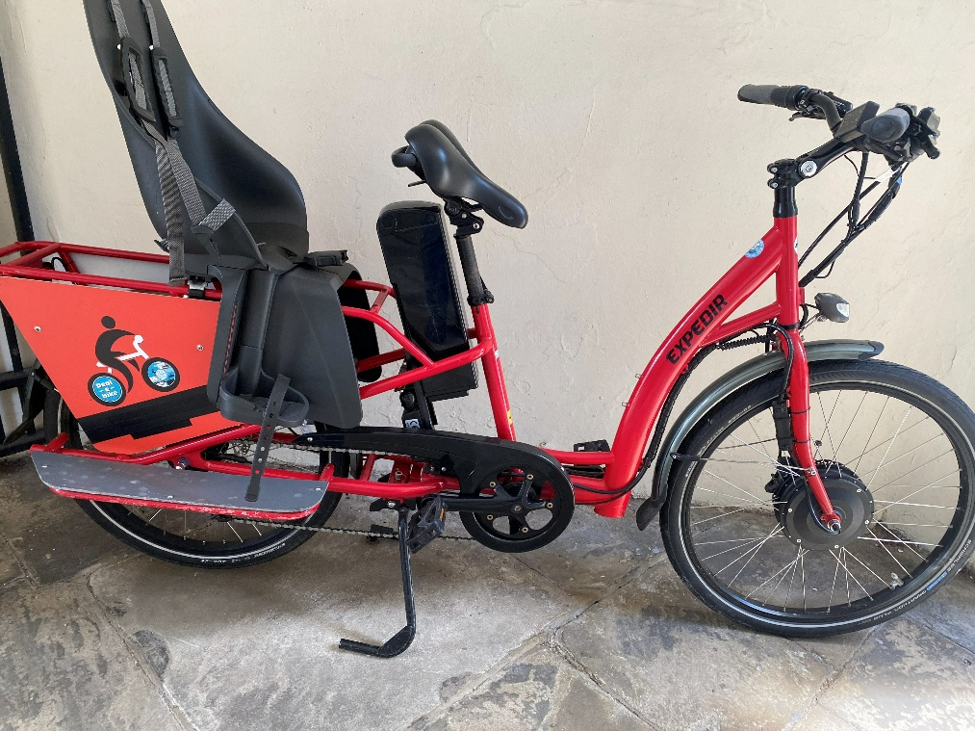
Application form 2026
Deal Town Council
Please add any additional information you want to give us on a separate sheet.

- Your Organisation
Name of organisation

Contact name and position in organisation | NAME:  POSITION:
Contact details | ADDRESS:  TEL:  EMAIL:
Registered charity / CIO | YES/NO: | Charity No:
Co. Ltd by Guarantee  or CIC | YES/NO: | Company No:
Community Group,  Club or Association | YES/NO: | Details:
Other | YES/NO: | Details:

- E-bikes
Please describe what the E-bike/s would be used for
What will be the impact of the E-bikes to your organisation?

What proportion of your members or beneficiaries live in Deal town? | …………….%
How many E-bikes would you want to take ownership of? | Model | Quantity
How many E-bikes would you want to take ownership of? | Ezee Bike Sprint: Step-Through model (2 Available)
How many E-bikes would you want to take ownership of? | Ezee Bike Forza: Step-Through model (1 Available)
How many E-bikes would you want to take ownership of? | Ezee Bike Forza: Cross bar model (2 Available)
How many E-bikes would you want to take ownership of? | Ezee Bike Expedir: Step-Through model (1 Available)
How many E-bikes would you want to take ownership of? | Any type available

Conditions of Transfer Used E-bikes
- From the date of transfer of ownership, Deal Town Council will not be responsible for the E-bike/s, batteries, or battery charger.
- Each E-bike comes with 2 batteries and one charger all originally supplied by the manufacture’s agent. (not aftermarket)
- Transfers will be on an ‘as seen’ basis and Deal Town Council will not pass on any guarantee or warranty whatsoever.
- Organisations are responsible for ensuring that they comply with all legal and statutory requirements for the use of the E-bike/s.
- Deal Town Council will not be responsible for any future maintenance charges relating to the E-bike/s.
- Acknowledgment of the transfer of ownership from Deal Town Council is required on promotional literature, websites and on social media. The Deal Town Council logo will be supplied on request for this purpose.

- Declaration.

I declare that the information given is correct

I have read and agree to adhere to the conditions of the Transfer of used E-bikes agreement.

Signed ………………………………. Date ………………….

Completed forms must be returned to the Responsible Finance Officer, Deal Town Council, Town Hall, High Street, Deal, Kent CT14 6TR or Email to: paul.bone@deal.gov.uk

The declaration at the end of the application form must be signed and dated, forms sent in electronically require either a scanned copy of the final page with signature or a final signed page to be submitted by post.
All applicants will be advised that their form is being processed within 5 working days of receipt.

For Town Hall use only.
Date application form received
Form checked by
Date application validated by R.F.O.
Date of committee meetings when application will be considered
Decision
Date applicant notified of decision

