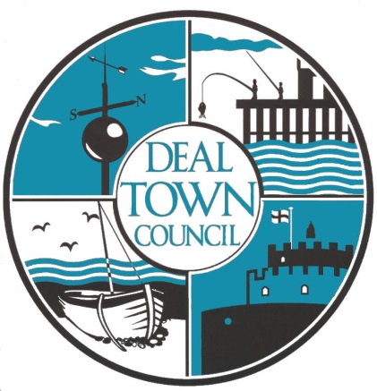
DEAL TOWN COUNCIL
EMERGENCY GRANT AID

DEAL TOWN COUNCIL EMERGENCY GRANT AID
DEAL TOWN COUNCIL’S GRANT AID STATEMENT:
Deal Town Council will award emergency grants to local organisations, community groups, clubs and small local businesses to help them support vital services to the community as a result of the current COVID-19 outbreak

Introduction
In view of the current COVID 19 outbreak Deal Town Council has put aside an initial £10,000 to help fund essential local services that would otherwise not be able to continue.

GENERAL GRANT AID GUIDELINES
- Deal Town Council will consider applications for financial assistance from any of the following;
    - Not for profit local organisations and community groups based in Deal or with a substantial number of beneficiaries in Deal.
    - Registered charities based in Deal or with a substantial number of beneficiaries in Deal.
    - Private businesses may in exceptional circumstances apply for financial support for projects which are clearly for the benefit for the residents of Deal
- Applications must be made using the appropriate form that is available to download from the Deal Town Council’s website; www.deal.gov.uk . The RFO can advise on completion of the form.
- Applicants will be required to show how the current outbreak of COVID-19 is affecting their ability to serve the residents of Deal.
- Applicants will be required to show how receiving an emergency grant would assist in providing essential services the residents of Deal.
- Grants are limited to only one award per organisation.
- Grants will not be awarded for specifically religious or party political purposes.
- Grants may only be used by the applicant for the named project and cannot be used to support payments by way of grant or donation to any other individuals

1. ELIGIBILITY
These organisations may apply:
a) Not for profit local organisations and community groups based in the Deal Town Council area or with beneficiaries exclusively or predominantly in the Deal Town Council area.
b) Registered charities based in the Deal Town Council area or with beneficiaries exclusively or predominantly in the Deal Town Council area.
c) Private businesses may in exceptional circumstances apply for financial support for services which are clearly for the benefit for the residents of Deal

2. GRANT AWARD
Grants may be awarded up to £2,000.
3. HOW TO APPLY
A full application form must be supplied which clearly demonstrates the need for emergency Grant Aid assistance and the contribution made to the community that is provided. Supporting documents may be required.
Applications will be considered by the Grants Sub-Committee. Sub-Committee members make a recommendation for the Responsible Finance Officer in liaison with the Town Clerk to consider based upon the benefit to the residents of Deal.
The decision of the Officers will be final.
4. PAYMENT
Successful applications will be paid by Bank transfer within 5 working days of decision

Deal Town Council

Emergency Grant Aid Application Form
Grants up to £2,000

- Your Organisation
Name of organisation

Postal address of organisation
Contact name and position in organisation

Contact details
(telephone number and e-mail)
Registered charity number | YES/NO: | Charity Number:
Co. Ltd by Guarantee | YES/NO: | Company Number:
Social Enterprise/CIC | YES/NO: | Details:
Community Group/Club/  Association | YES/NO: | Details:
Other | YES/NO: | Details:
- Your Grant Application
Please give details of the services that you supply to the residents of Deal
Please provide details of how many volunteer hours per week are included in delivering your services to the residents of Deal
Please explain why the current outbreak of COVID-19 is affecting your ability to serve the residents of Deal
Please explain what the result of you receiving an emergency grant would be and how it would assist you in providing essential services to the residents of Deal.

- Financial Details | Item |  | Cost
Please detail how the grant would be spent
 | Total cost
Amount requested from Deal Town Council
 | Name:
 | Date:

Completed forms must be returned to the Responsible Finance Officer, Deal Town Council, by e-mail: paul.bone@deal.gov.uk .

Grant Conditions

- The grant can only be used for the purpose stated in the application and Deal Town Council reserves the right to reclaim any grant not being used for the specified project/activity.
- Organisations are responsible for ensuring that they are in compliance with all legal and statutory requirements.
- Should for any reason the organisation disband during the period of the grant Deal Town Council may ask for all or part of the grant to be paid back.
- Prior approval of Deal Town Council is required if any change of the purpose of the grant is required.
- Organisations must contact Deal Town Council before disposing of any equipment or resources purchased or part purchased within 3 years of receiving a grant from Deal Town Council.
- Deal Town Council will monitor the use of the grant through the Grant Monitoring Form.
- Acknowledgment of the financial support received from Deal Town Council is required on documentation and the promotional literature or other media operation. The Deal Town Council logo will be supplied on request for this purpose.
- All successful applicants will be required to complete the Grant Monitoring Form. No further applications will be accepted if there is an outstanding Grant Monitoring Form.
- To be eligible for a grant an organisation shall not discriminate on the grounds of racial origin, gender, disability, age (expect for obvious reasons, such as becoming a member of a youth club), and political or religious persuasion.
- Should any of these conditions not be met it could result in the award being withdrawn, the grant having to be repaid and future grant applications being refused.

For Town Hall use only.
Date application form received

Form checked by

Date application validated by R.F.O.

Decision

Date applicant notified of decision

