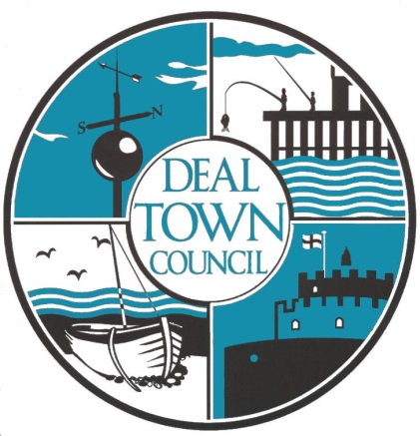
DEAL TOWN
GRANT FUND

Deal – A City of Sanctury

Purpose: - To promote community cohesion and support Asylum Seekers, Migrants and Refugees within the Deal Wards

Introduction
Deal Town Council has committed to becoming a ‘City of Sanctuary’.
Within this commitment the Council has resolved the following:-

Deal Town Council is committed to welcoming asylum seekers and refugees to Deal.

And

To ensure that all council policies and strategies do not disadvantage refugee and asylum seekers to the town.

To assist with these commitments, Deal Town Council has agreed to provide a new Grant Stream with a budget of £2,000 for the year 2023/24

GENERAL GRANT AID GUIDELINES
- Deal Town Council will consider applications for financial assistance for projects that promote community cohesion and support Asylum Seekers, Migrants, and Refugees within the Deal Wards.

- Deal Town Council will consider applications for projects that provide financial assistance or support to Asylum Seekers, Migrants, and Refugees in the Deal Wards from any of the following.

    - Not for profit local organisations and community groups based in Deal or with a substantial number of beneficiaries in Deal.
    - Registered charities based in Deal or with a substantial number of beneficiaries in Deal.
    - Private businesses may in exceptional circumstances apply for financial support for projects which are clearly for the support of Asylum seekers, Migrants, and Refugees in the Deal Wards.
    - Families looking after Asylum Seekers, Migrants, and Refugees in the Deal Wards.
    - Asylum Seekers, Migrants, and Refugees in the Deal Wards themselves.

- Applications must be made in writing to the Responsible Finance Officer.
- The application must clearly demonstrate how the project will provide financial assistance or support Asylum Seekers, Migrants, and Refugees in the Deal Wards.
- Grants are limited to only one award per organisation per year.
- Grants will not be awarded for specifically religious or party political purposes.
- Grants may only be used by the applicant for the named project and cannot be used to support payments by way of grant or donation to any other individuals.

1. ELIGIBILITY
These organisations may apply:
- Not for profit local organisations and community groups based in Deal or with a substantial number of beneficiaries in Deal.
- Registered charities based in Deal or with a substantial number of beneficiaries in Deal.
- Private businesses may in exceptional circumstances apply for financial support for projects which are clearly for the support of Asylum seekers and Refugees in the Deal Wards.
- Families looking after Asylum seekers and Refugees in the Deal Wards. *
- Asylum seekers and Refugees in the Deal Wards themselves. *
- Deal Town Councillors may apply on behalf of any of the above.

* Individuals applying for grant assistance must supply a letter/email of support from one on the following.
1. The Council’s partner organisations (Samphire, KRAN, D.A.R.A).
2. A local support organisation (Foodbank, Citizens Advice Bureau etc).
3. An officer of Dover District Council e.g. Refugee Support Officer.
4. A serving member of Deal Town Council.

2. GRANT AWARD
The maximum grant award will be determined by the Finance and General Purposes Committee.

3. HOW TO APPLY
Applications may be made in writing to the Responsible Finance Officer by:-
Email: RFO@deal.gov.uk
Post: The Responsible Finance Officer, Town Hall, High Street Deal. CT14 6TR
Applications will be considered by the Town Clerk in liaison with the R.F.O. and the Chairperson of Deal Town Council.

4. PAYMENT
Successful applications will be paid by Bank transfer within 5 working days of decision.

General Grant Conditions

- The grant can only be used for the purpose stated in the application and Deal Town Council reserves the right to reclaim any grant not being used for the specified project/activity.
- Organisations are responsible for ensuring that they are in compliance with all legal and statutory requirements.
- Should for any reason the organisation disband during the period of the grant Deal Town Council may ask for all or part of the grant to be paid back.
- Prior approval of Deal Town Council is required if any change of the purpose of the grant is required.
- Organisations must contact Deal Town Council before disposing of any equipment or resources purchased or part purchased within 3 years of receiving a grant from Deal Town Council.
- Deal Town Council will monitor the use of the grant through the Grant Monitoring Form.
- Acknowledgment of the financial support received from Deal Town Council is required on documentation and the promotional literature or other media operation. The Deal Town Council logo will be supplied on request for this purpose.
- All successful applicants will be required to complete the Grant Monitoring Form. No further applications will be accepted if there is an outstanding Grant Monitoring Form.
- To be eligible for a grant an organisation shall not discriminate on the grounds of racial origin, gender, disability, age (except for obvious reasons, such as becoming a member of a youth club), and political or religious persuasion.
- Should any of these conditions not be met it could result in the award being withdrawn, the grant having to be repaid and future grant applications being refused.

