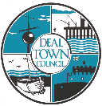
Deal Town Council
Undercroft Booking Form
Charity Table Top Sale

Saturday 3rd June – Saturday 30th September 2023
Date of Booking: (If more than one date is required please list in order of preference)

1………………………………………………………………………………………………………………………….…………………………………

2…………………………………………………………………………………………………………………………………..…………………………

3………………………………………………………..……………………………………………………………………………………………………

4……………………………………………………………………………………………………………………………………………………………..

Name of Charity/Organisation:………………………………………………………………………………………………………………

Charity Registration Number:……………………………………………………………………………………………………
Name and telephone number for person responsible for sale on the day, who will also ensure that the conditions of use are adhered to:

Name:……………………………………………………………………..

Telephone Number:………………………………………………

Address:………………………………………………………………………………………………………………………………………………….

.………………………………….………………………………………………………………………………………………………………………………………………

……………………………………………………………………………………………………………………Post Code:..…………………………………………

Email:………………………………………………………………………………………………..

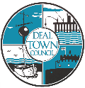

Permit to make a street collection or sale.

Applicants must apply to Dover District Council for a permit to make a street collection or sale. This can be completed online at the following address Street collections / sales (dover.gov.uk). A copy of the licence must be shown to Deal Town Council prior to the date of hire.

Selling or handling food in the Undercroft
If making, handling and selling food at a charity event in the Deal Town Hall Undercroft you are required to do so safely. Practical hygiene advice for caterers can be found at:
https://www.food.gov.uk/safety-hygiene/providing-food-at-community-and-charity-events

I confirm that I agree to the attached conditions of use and will adhere to them:

Name: ……………………………………………………………..Date: ……………………………………………..……..
Deal Town Council cares to ensure the security of personal data. This is done through appropriate technical measures and relevant policies. Data is kept for the purpose it was collected for and only for as long as is necessary. (See our Privacy Notice & Retention Policy online at: www.deal.gov.uk for further information)
Please indicate if you are happy for us to keep your personal data on file for the purpose of sending information regarding notification of booking in the future. (Please tick) Yes□ No □

Please return booking form to:
Joanne Harper, Event Manager
Deal Town Council
Town Hall
High Street
Deal
Kent
CT14 6TR
Tel: 01304 361999/07887491569
Email: Joanne.harper@deal.gov.uk
For office use only:
Booking confirmed:………………………………………..
Permit Received:…………………………………………….
Public Liability Insurance certificate: □ Received □ Valid
Undercroft Conditions of Use
- The Undercroft must be booked via Deal Town Council’s Event Manager.
- The Undercroft is only available for hire by charitable organisations for tabletop sales and is solely hired to the person, society, committee or other responsible person for the proposed collection or sale. Under no circumstances is the Undercroft to be sub-let to another organisation or private seller.
- Date and times of use are Saturdays between 8.00am and 1.00pm. Tables will be in place at 8.00am.
- A fee of £25.00 is required at the time of booking. Payment should be made via bank transfer and details will be sent to you on confirmation of the booking.
- No refunds will be given, but the booking may be transferred to another available date subject to availability.
- Tables will be arranged in a set format by a Deal Town Council Officer (please see overleaf) and must only be moved by a member of Deal Town Council staff in order to comply with Health and Safety regulations.
- All sale items are to be contained on or within the table space provided. Under no circumstances must anything be placed anywhere else within the Undercroft e.g. gates, window frames, doorways, or benches. The hirer must only sell goods or services for which they have permission. The sale of guns, crossbows, axes, swords or knives is not permitted.
- No advertising materials such as posters, banners, bunting or decorations should be attached to Deal Town Council property, including gates, walls, windows, doors, pillars, and noticeboards.
- All refuse must be removed and the Undercroft left tidy, goods must be packed away by 1.00pm.
- The hirer must have valid public liability insurance (copy of certificate required).
- If the hirer makes, handles and sells food at a charity event in the Deal Town Hall Undercroft they are required to do so safely. https://www.food.gov.uk/safety-hygiene/providing-food-at-community-and-charity-events.
- Applicants must apply to Dover District Council for a permit to make a street collection or sale under the Local Government Act 1972. This can be completed online at the following address Street collections / sales (dover.gov.uk). A copy of the licence must be shown to Deal Town Council prior to the date of hire.
- Smoking in the Undercroft is strictly prohibited.
- Failure to adhere to these conditions may result in future bookings being refused.
- Deal Town Council has a zero tolerance for unacceptable behaviour towards our staff. Violence against staff is a crime, and threatening or violent behaviour, which is rare, will not be tolerated in any form whatsoever.
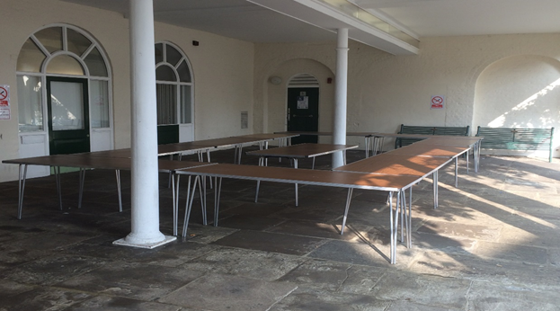

Deal Town Council Environmental Policy

(extract relevant to Town Hall hire)

Deal Town Council recognises that we face an unprecedented climate and environmental emergency. We have committed to using our power and influence to protect and improve the environment and encourage and support others to do the same, in addition to fulfilling our statutory environmental responsibilities and complying with all legal and other requirements.
We will, amongst other things:

- Promote environmental awareness within the community and work with the local community in partnerships to achieve environmental change

- Reduce the consumption of energy and water across all of our activities

- Continue to improve our performance to prevent all types of pollution and reduce CO2 and other harmful emissions from our activities

- Work closely with our suppliers and contractors to reduce the social and environmental impact of goods and services by considering such issues as carbon footprint, single use plastics, and fair trade goods

- Use products and materials such as paper efficiently and specify goods that, wherever possible, have a minimal environmental impact in the extraction or sourcing of materials, manufacture, use and disposal

- Minimise the production of waste from our own activities and adhere to the principles of the waste hierarchy - reducing, reusing, recycling or composting wherever possible
We affect the environment through our services and policies, enforcement of laws and regulations, the choices we make when buying goods and services – as well as our role as a community leader. In recognising the climate and environmental emergency we acknowledge that environmental concerns have primacy over other matters and that radical action is needed to facilitate the change required to avoid the worst impacts of climate change.
We will encourage the local community and other partners and stakeholders to take action too, through the provision of information and support, as well as advocacy.

