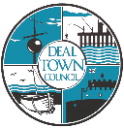
Deal Town Council
Undercroft Booking Form
Charities, Local organisations & Community groups.
Date of Booking: (If more than one date is required, please list in order of preference)
Saturdays & Wednesdays only.
1

2

3

Nature of use-
Number of tables required, (maximum 12)
Name of Charity/Organisation:
Charity Registration Number, (if applicable):
Name and telephone number for person responsible on the day, who will also ensure that the conditions of use are adhered to:

Name:

Telephone Number:

Address.

Post Code:

Email:

We will try to facilitate first choices, but where multiple applicants have applied for the same date, this will not be possible. Priority goes to registered charities.
This form is valid between October 2025 – October 2026.
All bookings are subject to a valid PL insurance, an excepted Risk assessment and all T&C’s being met. The Facilities Manager has the final responsibility for the suitability of bookings, and may need to move or amend bookings.

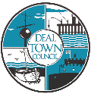

Permit to make a street collection or sale.

Applicants must apply to Dover District Council for a permit to make a street collection or sale. This can be completed online at the following address Street collections / sales (dover.gov.uk). A copy of the license must be shown to Deal Town Council before the hire date.

Selling or handling food in the Undercroft If making, handling and selling food at a charity event in the Deal Town Hall Undercroft you are required to do so safely. Practical hygiene advice for caterers can be found at:
https://www.food.gov.uk/safety-hygiene/providing-food-at-community-and-charity-events

Do you need a PRS license to Perform, (If yes, it is your responsibility to obtain one), | Please tick box to confirm you are compliant.
I confirm that I agree to the attached conditions of use and will adhere to them:
Signed:
Name: Date:
Deal Town Council cares to ensure the security of personal data. This is done through appropriate technical measures and relevant policies. Data is kept for the purpose it was collected for and only for as long as is necessary. (See our Privacy Notice & Retention Policy online at: www.deal.gov.uk for further information)
Please indicate if you are happy for us to keep your personal data on file for the purpose of sending information regarding notification of booking in the future. (Please tick) Yes□ No □

Please return booking form to:
Gary Simpson.
Facilities manager.
Deal Town Council
Town Hall
High Street
Deal
CT14 6TR
Tel: 01304 361999/07785629006
Email: gary.simpson@deal.gov.uk
For office use only:
Booking confirmed:
Permit Received:
Public Liability Insurance certificate: □ Received □ Valid
Undercroft Conditions of Use
- The Undercroft must be booked via Deal Town Council’s Facilities Manager.
- Deal Town Council will only consider applications for hire of the undercroft, from any of the following.
Not for profit local organisations and community groups based in the Deal Town council area or with beneficiaries exclusively or predominantly in the Deal Town council area.
Registered charities based in the Deal Town council area or with beneficiaries exclusively or predominantly in the Deal Town council area.
Social enterprise companies or community interest companies based in the Deal Town council area or with beneficiaries exclusively or predominantly in the Deal Town council area.
- Under no circumstances is the Undercroft to be sub-let to another organisation or private seller. Sharing is allowed but the signatory is the person responsible for ensuring compliance with the rules.
- Individuals will not be eligible to hire for personal gain.
- Date and times of use are:
Saturdays between 9.00am and 1.00pm.
Wednesdays 10 am – 2pm.
- Wednesdays are only to be used for exhibitions and community awareness, no sales or performances allowed.
- Saturdays are available for tabletop sales, musical performances, community awareness and exhibitions.
- Musical performances are to be of an acoustic variety only, with the volume levels set to cause minimal sound nuisance to surrounding areas. (not exceeding 85dbs). The council officer will be the final arbitrator on volume levels.
- For any performance requiring a license, (PRS or other), it is the hirer’s responsibility to obtain one.
- Risk Assessments are required for all events and must be completed by the hirer. No booking will be deemed confirmed until an excepted RA is received.
- A fee of £25.00 is required at the time of booking confirmation. Payment should be made via bank transfer and details will be sent to you on confirmation of the booking.
- No refunds will be given, but the booking may be transferred to another available date subject to availability.
- Tables will be arranged in a set format by a Deal Town Council Officer (please see overleaf) and must only be moved by a member of Deal Town Council staff to comply with Health and Safety regulations.
- All sale items are to be contained on or within the table space provided. Under no circumstances must anything be placed anywhere else within the Undercroft e.g., gates, window frames, doorways, or benches. The hirer must only sell goods or services for which they have permission. The sale of guns, crossbows, axes, swords, or knives is not permitted.
- No advertising materials such as posters, banners, bunting, or decorations should be attached to Deal Town Council property, including gates, walls, windows, doors, pillars, and noticeboards.
- Use of the undercroft will not be granted for religious or political purposes.
- All refuse must be removed, and the Undercroft left tidy, goods must be packed away by the end of hire time.
- The hirer must have valid public liability insurance (copy of certificate required).
- If the hirer makes, handles, and sells food at a charity event in the Deal Town Hall Undercroft, they must do so safely. https://www.food.gov.uk/safety-hygiene/providing-food-at-community-and-charity-events. No hot food is allowed to be sold.
- Deal Town Council will supply the tables, no extra tables are permitted. All power, toilets, and water must be sought elsewhere, unless previously agreed.
- Applicants must apply to Dover District Council for a permit to make a street collection or sale under the Local Government Act 1972. This can be completed online at the following address Street collections / sales (dover.gov.uk). A copy of the license must be shown to Deal Town Council prior to the date of hire.
- Smoking or vaping in the Undercroft is strictly prohibited.
- Failure to adhere to these conditions may result in future bookings being refused and the hire period curtailed.
- Deal Town Council has a zero tolerance for unacceptable behaviour towards our staff. Violence against staff is a crime, and threatening or violent behaviour, which is rare, will not be tolerated in any form whatsoever.
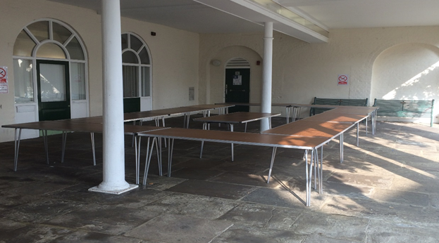

Deal Town Council Environmental Policy

(extract relevant to Town Hall hire)

Deal Town Council recognises that we face an unprecedented climate and environmental emergency. We have committed to using our power and influence to protect and improve the environment and encourage and support others to do the same, in addition to fulfilling our statutory environmental responsibilities and complying with all legal and other requirements.
We will, amongst other things:

- Promote environmental awareness within the community and work with the local community in partnerships to achieve environmental change.

- Reduce the consumption of energy and water across all our activities.

- Continue to improve our performance to prevent all types of pollution and reduce CO2 and other harmful emissions from our activities.

- Work closely with our suppliers and contractors to reduce the social and environmental impact of goods and services by considering such issues as carbon footprint, single use plastics, and fair-trade goods.

- Use products and materials such as paper efficiently and specify goods that, wherever possible, have a minimal environmental impact in the extraction or sourcing of materials, manufacture, use and disposal.

- Minimise the production of waste from our own activities and adhere to the principles of the waste hierarchy - reducing, reusing, recycling, or composting wherever possible.
We affect the environment through our services and policies, enforcement of laws and regulations, the choices we make when buying goods and services – as well as our role as a community leader. In recognising the climate and environmental emergency we acknowledge that environmental concerns have primacy over other matters and that radical action is needed to facilitate the change required to avoid the worst impacts of climate change.
We will encourage the local community and other partners and stakeholders to act too, through the provision of information and support, as well as advocacy.

