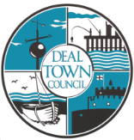
Deal Town Hall Booking Form
Chamber and/or Committee Room

Date of Hire: ……………………………………………………….….......................................................................................

Times required: Please note access will not be given any earlier than the time stated below.

Access to the Town Hall required from: ……………………………………………….. To: ..…………………………………………….

Event Start Time from: …………………………………………………………………………. To: ………………………………………..……

Name of Hirer: ……………………………..…………………………………………………………………………………………………………………………..………

Name of responsible person at the event: …………………………………………………………………….…………………………..
(this must be someone who will be present for the duration of the booking)

Name of Organisation (If applicable): ………………………………………………………………………………………………………..

Registered Charity Number if applicable: …………………………………………………………………………………………………….

Address: ……………………………………………………………………………………………………………………………………………………

………………………………………………………………………………………………………………………………………………………………………..

……………………………………………………………………………………………………………Postcode: …………………………………………

Telephone Number: …………………………………………. Email address: ………………….…………………………………………….

Purpose/Type of Function/Event: ……………………………………………………………………………………………………………..

…………………………………………………………………………………………………………………………………………………………………

Please tick appropriate box for rooms required:
Chamber Committee Room

Chamber | Room Layout…………………………………………………………………… (i.e A, B, C, D, E) Refer to pictures of examples. If you would like a variation on any of the layouts or more options, please contact the Event Manager who can assist you with this.
Committee Room | Room Layout:……………………………………………………………..………(i.e A,B,C,D)
Please detail any further information required to assist with your booking requirements Please note: the maximum number of persons attending any event must not exceed the numbers below permitted under fire regulations:  Chamber:  Theatre Style: Up to 80 people  Seated at tables: Up to 70 people  Seated at tables and Dancing: Up to 50 people  Committee Room: Maximum 25 people | Number of Guests:……………………

Additional Information - please tick appropriate adjacent box
Kitchen - Please indicate if you require use of the following:  Use of kitchen; to include plates, cups, saucers, cutlery, glasses, glass water jugs and hot water urn, cooker & microwave.  (£10.00)  Table cloth hire (£7.00 Per cloth) | Yes No Urn  Please indicate no. required
Digital projector & Screen (£10.00)

Free Wi-Fi Access FREE

Roaming Microphone FREE

Piano (Please note; tuning is the responsibility of the hirer)

Are you intending to sell alcohol at your event? (Please note if the answer is yes you must apply to Dover District Council for a license and supply Deal Town Council with a copy 1 week prior to your event.)

Are you intending to provide alcohol at your event? (If yes you must fill out the enclosed appropriate form.
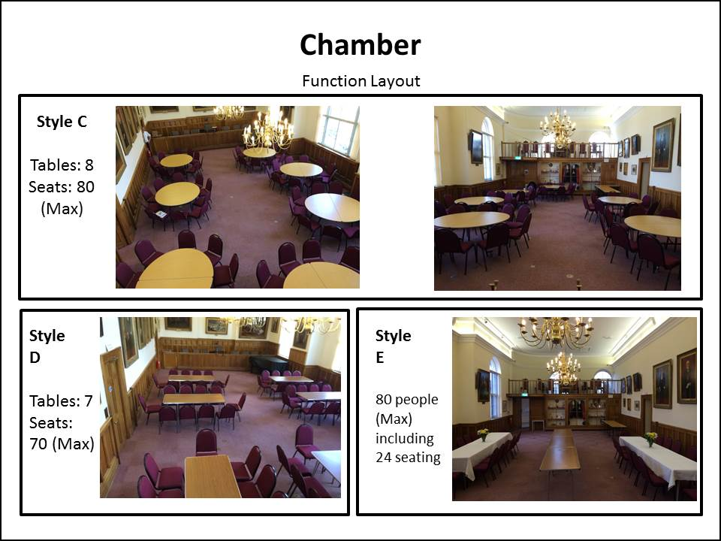
Deal Town Council cares to ensure the security of personal data. This is done through appropriate technical measures and relevant policies. Data is kept for the purpose it was collected for and only for as long as is necessary. (See our Privacy Notice & Retention Policy online at: www.deal.gov.uk for further information)If you would like a variation on any of the layouts or more options please contact the Event Manager who can assist you with this. 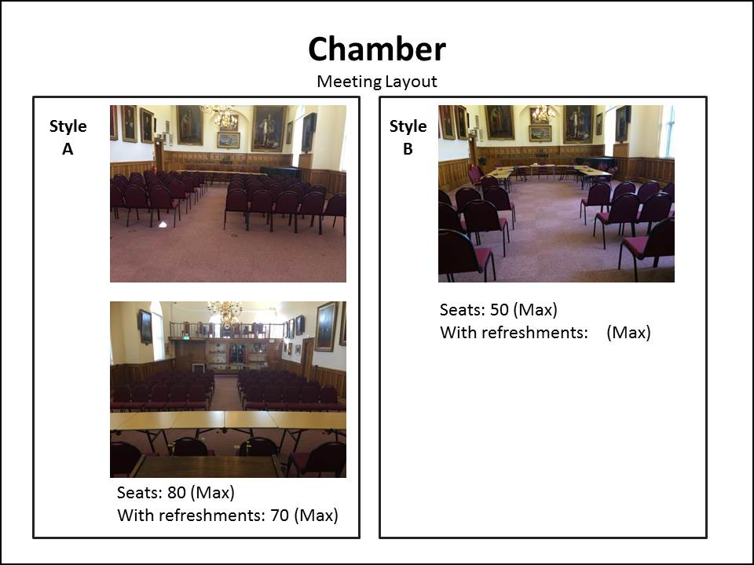

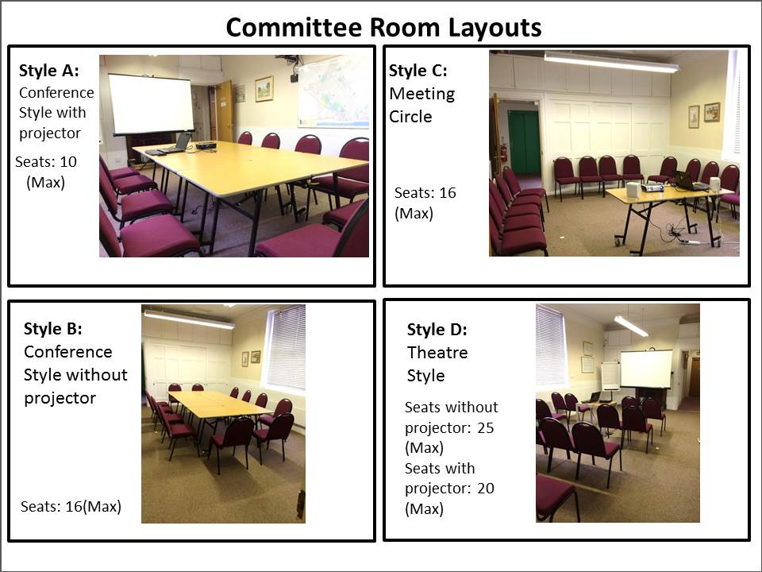
DEAL TOWN HALL HIRE

- Deal Town Hall is available for hire between the hours of 09.00 and 23.00 Sunday to Thursday and 09.00 to Midnight on Friday and Saturday.
- The Town Hall must be vacated by midnight in all instances.
- No booking will be accepted from any persons under the age of 18.
- Deal Town Hall is not available for hire for hen/stag parties, 18th and 21st birthday parties, disco or children’s parties.
- The Town Hall and Undercroft are not available for hire from Christmas Eve until 2nd January each year.

Deposits and Charges
- Full payment is required at the time of booking if the hire charge is less than £50, this will be non-refundable in the event of cancellation.
- A non-refundable deposit of £50 is required at the time of booking, . Please note the final invoice for the booking will include any additional time incurred if the event/function exceeds the original booked time.
- Booking is charged by the hour.
- The Hirer/Responsible Person will be liable for any damages/breakages that occur during the function.

Cancellations
- In case of emergency on the day of your booking, please telephone 01304 361999 during office hours. The out of office telephone number 07342276055 is available on the date of the event/function 30 minutes before the booking time.
- Should you need to cancel your booking you must advise the Event Manager as soon as possible, in writing, at least one week before the event, failure to do so will mean that you are charged the full amount.
- Deal Town Council reserves the right to cancel the hiring of the Town Hall for any purpose at its absolute discretion, or if it is rendered unusable for Health and Safety reasons. If for any such reason the booking is cancelled, the Council will give the maximum practicable notice and refund the booking fee but will not otherwise be liable to the Hirer.
- Deal Town Council reserves the right to refuse any booking at its absolute discretion without giving reasons.

Amenities/Facilities
- Chamber Room Capacity Theatre Style: Up to 80 people
Seated at tables: Up to 70 people
Seated at tables and Dancing: Up to 50 people
- Committee Room Capacity Up to 25 people
- Lift
- Kitchen
- Piano (Tuning of the piano is the responsibility of the hirer if required and must be pre-arranged with the Event Manager). Under no circumstances must the piano be moved, or anything placed on top.
- Screen & Projector
- Microphones
- Tablecloth Hire
- A Deal Town Council Officer will be on duty throughout the hire period.

Accessibility
- The Town Hall Chamber and Committee Room are on the first floor. A passenger lift is available for wheelchair users, disabled access and general use.
- Disabled access toilets are available on the ground and first floor.
- A hearing loop is provided for the benefit of hearing aid users.
- Free WI-FI internet access is available on request.
- There is a pay and display car park at the rear of the Town Hall including 1 disabled parking bay.

Health & Safety
- Tables and chairs will be set up for the event/function by arrangement. (Please note that for health & safety reasons tables must only be moved by Deal Town Council Staff)
- When hire includes use of the kitchen, the Hirer/Responsible Person must ensure proper knowledge as to the safe use of the equipment. The cooker is only to be used by persons authorised by the hirer who will ensure that they are able to use it safely, this includes any outside caterers.
- No Smoke making appliances or naked flames may be used within the Town Hall
- Prior permission is required for the use of any electrical equipment. The Hirer/Responsible Person must ensure that all portable equipment brought onto the premises has a current Portable Appliance Test or is less than 3 years old (proof of this may be requested).
- Maximum weight limit for standard chairs is rated up-to 113Kg (17.8) stone. There are 5 chairs rated up to 240kg (37.7 stone) available on request.
- The Town Hall and Undercroft are strictly No Smoking Zones.

General hiring Conditions
- No decorations are to be attached to walls, doors, windows or chandeliers without prior permission from the Event Manager.
- No animals are permitted within the Town Hall without prior written permission from the Town Clerk. This excludes Guide Dogs.
- Access is not permitted to the Mayor’s Bench or the balcony.
- The Council will not under any circumstances accept responsibility or liability in respect of any damage to or loss of any goods, articles or property of any kind brought into or left at the Town Hall either by the Hirer for their own purposes or by any other person or left or deposited with any officer or employee of the Council.
- All items brought into the Town Hall are to be removed from the premises by the hirer before the end of the hire period. All areas used are to be left in a clean and tidy condition.
- The use of balloons and other single use plastics (e.g. straws, stirrers, cups, cutlery, plates, etc.) are not permitted in the Town Hall due to the Council’s commitment to supporting Plastic Free Deal initiatives. We would encourage hirers to utilise the Council’s cutlery, crockery and glassware, (available at a small cost) or suitable sustainable alternatives.
- Cameras and video recorders are permitted in the Town Hall; however, flashlights must not be pointed directly at paintings within the room as they can be damaged by flashlight.
- All employees and any other person acting on behalf of the Council are prohibited from accepting tips, gifts or other forms of reward.
- If alcohol is to be sold at your event or covered in the ticket price the hirer is responsible for obtaining a Temporary Event Notice licence from Dover District Council. Deal Town Council requires a copy of the agreed licence before the event takes place. For further information from Dover District Council please contact them direct or view their guidance notes on their website at www.dover.gov.uk/Business/Licensing/Licensing-Objectives.
- If alcohol is being provided free of charge at your event, the Hirer/Responsible Person will be responsible and must read, sign and return the enclosed form
- Please note that Christmas decorations will be in place at the end of November and throughout December in the Town Hall and Undercroft. You are still very welcome to book during these months, but the Christmas decorations will remain in place.
- Deal Town Council commits to the Breastfeeding Welcome Scheme (policy available on request).
- Deal Town Council commits to being a Fair Trade Town and sources fair trade products wherever possible, and we strongly encourage our hirers to do the same.

Responsibility of the Hirer
- The name of the Hirer/Responsible Person must be provided at the time of booking, this person must be present for the duration of the hire period and is required to be aware of the procedures in case of fire and the location of fire exits, alarms and extinguishers, details of which are on display on both floors.
- Should the Hirer/Responsible Person change prior to the booking, the Events Manager must be informed.
- No other persons will be permitted into the building until the Hirer/Responsible Person is present.
- On arrival at the Town Hall the Hirer/Responsible Person must make themselves known to the officer on duty in order to sign the council attendance register, they will then be provided with a pager. At the end of the hire period the hirer/responsible person must inform the officer on duty when all guests have vacated the premises in order to be signed out.
- It is also the responsibility of the hirer to carry out a risk assessment for their event or function, including use of the kitchen.
- The Hirer/Responsible Person must ensure that only authorized and invited persons attend the function/event and that all guests behave appropriately, and children are supervised at all times.
- The Council will not under any circumstances accept responsibility or liability for death or injury to any person attending the hall for a function, except where any death or injury is due to the negligence of the Council.
- The Hirer/Responsible Person & Guests shall be restricted to the use of the room/s that they have specifically hired.
- The Hirer/Responsible Person will ensure that their rubbish is taken with them following the event, with the exception of glass bottles which the Council will recycle. We strongly encourage hirers to sort their plastic, paper and food waste and recycle appropriately, in line with our Environment Policy.

Declaration

Please sign and return to the Events Manager with your booking form.
I confirm that I have read and understood the Conditions for Hire of Deal Town Hall and agree that I will adhere to them.
Print Name: …………………………………………………………………………………………………………………..
Signature: ……………………………………………………….…………………………………………………………….
Date: .…………………………………………………………………………………….……………………………..………

Return to:

Joanne Harper
Events Manager
Deal Town Council
Town Hall
High Street
Deal
CT14 6TR
01304 361999
E: joanne.harper@deal.gov.uk

FOR OFFICE USE ONLY:
DATE | NAME OF HIRER | ARRIVAL TIME | EXIT TIME | SIGNATURE OF HIRER | SIGNATURE OF DTC OFFICER ON DUTY

Deal Town Council Environmental Policy

(extract relevant to Town Hall hire)

Deal Town Council recognises that we face an unprecedented climate and environmental emergency. We have committed to using our power and influence to protect and improve the environment and encourage and support others to do the same, in addition to fulfilling our statutory environmental responsibilities and complying with all legal and other requirements.
We will, amongst other things:
- Promote environmental awareness within the community and work with the local community in partnerships to achieve environmental change

- Reduce the consumption of energy and water across all of our activities

- Continue to improve our performance to prevent all types of pollution and reduce CO2 and other harmful emissions from our activities

- Work closely with our suppliers and contractors to reduce the social and environmental impact of goods and services by considering such issues as carbon footprint, single use plastics, and fair trade goods

- Use products and materials such as paper efficiently and specify goods that, wherever possible, have a minimal environmental impact in the extraction or sourcing of materials, manufacture, use and disposal

- Minimise the production of waste from our own activities and adhere to the principles of the waste hierarchy - reducing, reusing, recycling or composting wherever possible
We affect the environment through our services and policies, enforcement of laws and regulations, the choices we make when buying goods and services – as well as our role as a community leader. In recognising the climate and environmental emergency we acknowledge that environmental concerns have primacy over other matters and that radical action is needed to facilitate the change required to avoid the worst impacts of climate change.
We will encourage the local community and other partners and stakeholders to take action too, through the provision of information and support, as well as advocacy.
Deal Town Council

Providing alcohol at your event free of charge

If you are intending to provide alcohol free of charge at your event in the Town Hall, the hirer/responsible person must adhere to the following Licensing Objectives:

- Prevention of Crime and Disorder
- Public Safety
- Prevention of Public Nuisance
- Protection of Children from Harm
It should be noted that the following, among other things, are offences under the Licensing Act 2003:

- the sale or supply of alcohol to children under 18 years of age (maximum fine on conviction is a fine up to level 5 on the standard scale, currently £5,000);

- allowing the sale of alcohol to children under 18 (maximum fine on conviction is a fine up to level 5 on the standard scale, currently £5,000);

- knowingly allowing the consumption of alcohol on the premises by a person aged under 18 (maximum fine on conviction is a fine up to level 5 on the standard scale, currently £5,000);

- allowing disorderly behaviour on the premises (maximum fine on conviction is a fine up to level 3 on the standard scale, currently £1,000);

- the sale of alcohol to a person who is drunk (maximum fine on conviction is a fine up to level 3 on the standard scale, currently £1,000);

- obtaining alcohol for a person who is drunk (maximum fine on conviction is a fine up to level 3 on the standard scale, currently £1,000);

- knowingly allowing a person aged under 18 to make any sale or supply of alcohol unless the sale or supply has been specifically approved by the premises user or any individual aged 18 or over who has been authorised for this purpose by the premises user (maximum fine on conviction is a fine up to level 1 on the standard scale, currently £200); and

- knowingly keeping or allowing to be kept on the premises any smuggled goods which have been imported without payment of duty or which have otherwise been unlawfully imported (maximum fine on conviction is a fine up to level 3 on the standard scale, currently £1,000).

Declaration:
I confirm that I have read and understood the above guidance for providing alcohol at an event and will be the person responsible for ensuring that the objectives are followed for my event.
Print Name: ………………………………………………………………………………………………………………………………….
Signature: …….……………………………………………………………………………………………………………………………..
Date: …………………………………………………………………………………………………………………………………………...

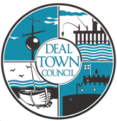
Deal Town Hall
Room Hire Charges

CHAMBER
Monday to Friday  Monday to Thursday  Friday | 09.00-18.00  18.00-23.00  18.00-23.00 | £20.00 p/h (Minimum booking of 3 hours)  £25.00 p/h  £30.00 p/h
Saturday  Saturday | 09.00-18.00  18.00-24.00 | £35.00 p/h (Minimum booking of 3 hours)  £40.00 p/h
Sunday &  Bank Holiday | 09.00-18.00  18.00-23.00 | £52.50 p/h (Minimum booking of 3 hours)  £60.00 p/h

COMMITTEE ROOM
Monday to Friday | 09.00-23.00 | £15.00 p/h (minimum booking of 3 hours)
Saturday | 09.00-24.00 | £25.00 p/h (Minimum booking 3 hours)
Sunday &  Bank Holiday | 09.00-23.00 | £37.50 p/h (minimum booking 3 hours)

If Chamber and Committee room are both hired together a discount of £10 per hour applies
Additional Hire

- Use of kitchen; to include plates, cups, saucers, cutlery, glasses, glass water jugs and hot water urn, cooker & microwave. (£10.00)
- Tablecloth hire: (£7.00ea)

- Digital projector & Screen (£10.00)

- Free Wi-Fi Access FREE

- Roaming Microphone FREE

- Piano (Please note; tuning is the responsibility of the hirer) FREE

