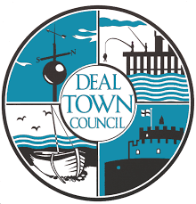
WEDNESDAY MARKET
STALLHOLDER APPLICATION FORM
(Please use block capitals to fill in this form)

Name: _____________________________________________________________

Trading name: _______________________________________________________

Business Address:___________________________________________________
________________________________________ Postcode: _________________

Telephone Number: ________________________Email: ____________________ ________________________

Core Product Line:

Secondary Product Line:

If you change your trade or develop new lines you must fill out a new application form

Applicant Statement

I, the undersigned, declare that the information provided is correct and I agree to uphold the rules and standards of the market and ensure that any of my employees do likewise:

Please tick if you agree to your details being used by Deal Town Council in advertising materials about the Markets

Signed: ………………………...................................................

Print Name:……………………………….....................................Date……………………………………………

Please return to: The Market Officer

Tel: 07877 806870 E-mail: chris.hobbs-east@deal.gov.uk

Deal Town Council cares to ensure the security of personal data. This is done through appropriate technical measures and relevant policies. Data is kept for the purpose it was collected for and only for as long as is necessary. (See our Privacy Notice & Retention Policy online at: UK GDPR - Deal Town Council for further information)

For Office use only:
Certificate: | Seen:
Public Liability insurance
Environment Health rating (if applicable)

